**Introduction:**

The Fee Management System is a digital solution designed to efficiently handle all aspects of fee collection, processing, and reporting in educational institutions. It automates the management of student dues, payments, and receipts while ensuring transparency and accuracy in financial records. This system benefits administrators, students, and accountants by streamlining fee-related operations.

**Objectives:**

* Automate fee collection and reduce manual workload.
* Maintain accurate and secure financial records.
* Enable easy tracking of dues, payments, and receipts.
* Generate timely financial reports for students and management.
* Improve user accessibility and data transparency.

**Entity Description Table:**

|  |  |  |
| --- | --- | --- |
| Entity Name | Description | Key Attributes |
| Student | An individual enrolled in an institution. Each student has a unique identity and may be associated with fee payments, dues, and reports. | Student_ID, Name, Email, Phone, Address, Class, Section |
| Fee Structure | A defined schedule and breakdown of tuition and other fees applicable to a specific course or program. It is assigned to students and helps determine dues. | FeeStructure_ID, Class, Tuition_Fee, Exam_Fee, Lab_Fee, Other_Charges, Total_Fee |
| Payment | A transaction representing the payment made by a student against their dues. Each payment is recorded and linked to a receipt. | Payment_ID, Student_ID, Amount_Paid, Date |
| Due | Represents the amount a student still owes as per the fee structure. Due entries are updated based on payments. | Due_ID, Student_ID, Amount_Due, Due_Date |
| Receipt | A formal document acknowledging a payment made by a student. Generated for each successful payment. | Receipt_ID, Payment_ID, Student_ID, Amount, Date_Issued |
| Report | A compiled summary of a student’s financial activity including fee payments, dues, and balances. | Report_ID, Generated_Date, ReportType |

**Laravel Server:**

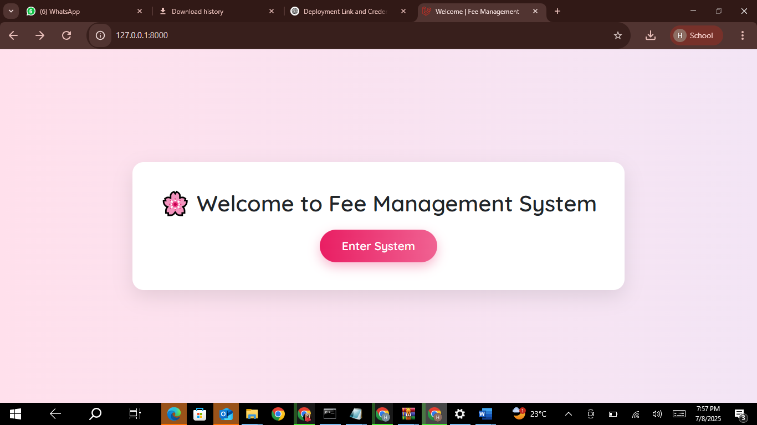

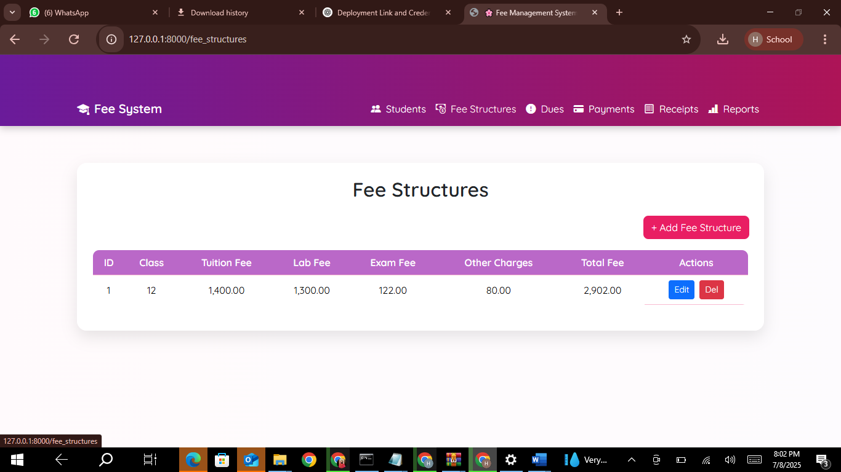

**Laravel deployment using Hostinger:**

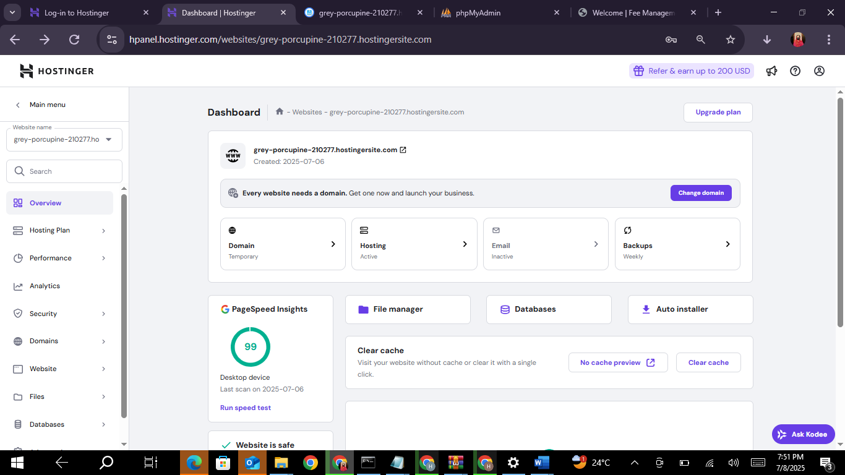

Hostinger Dashboard

**Step 1:** Exporting database via localhost/phpMyAdmin/

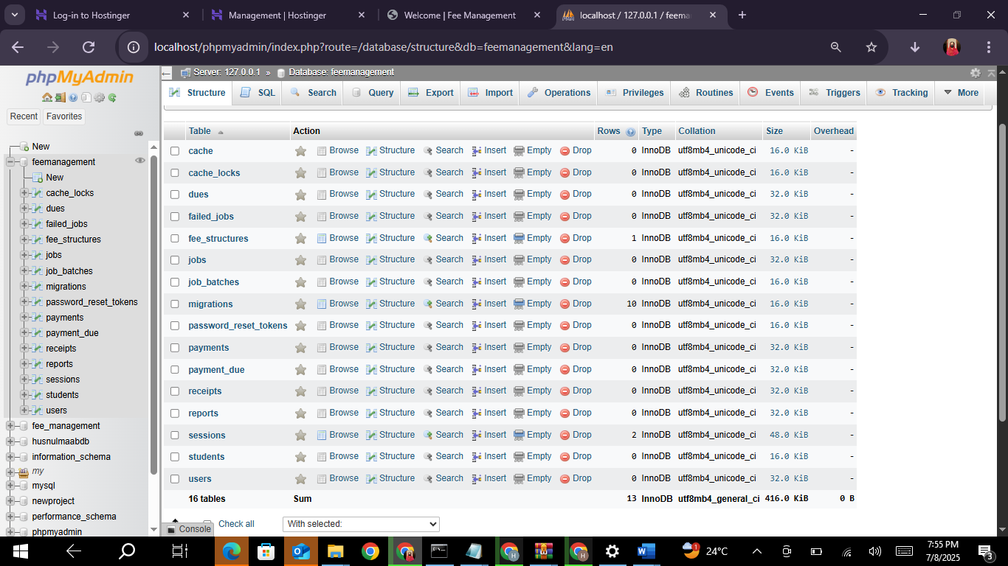

**Step 2:** Creating database on Hostinger and import the database that you have exported via phpMyAdmin

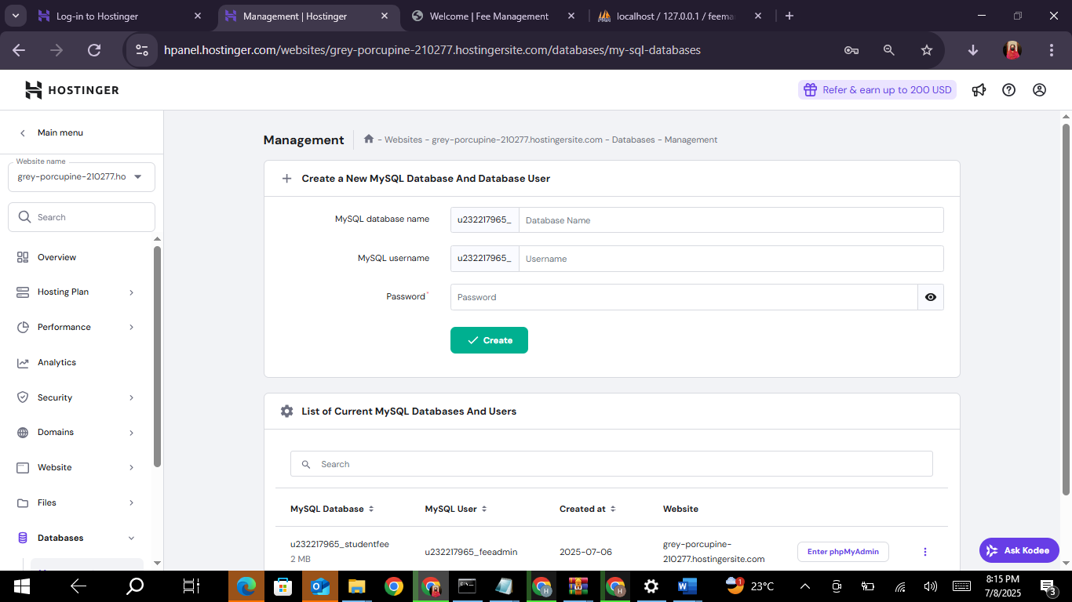

**Step 3:** Uploading zip file

* All files of database including htaccess and env should be at the front i.e. in the main folder

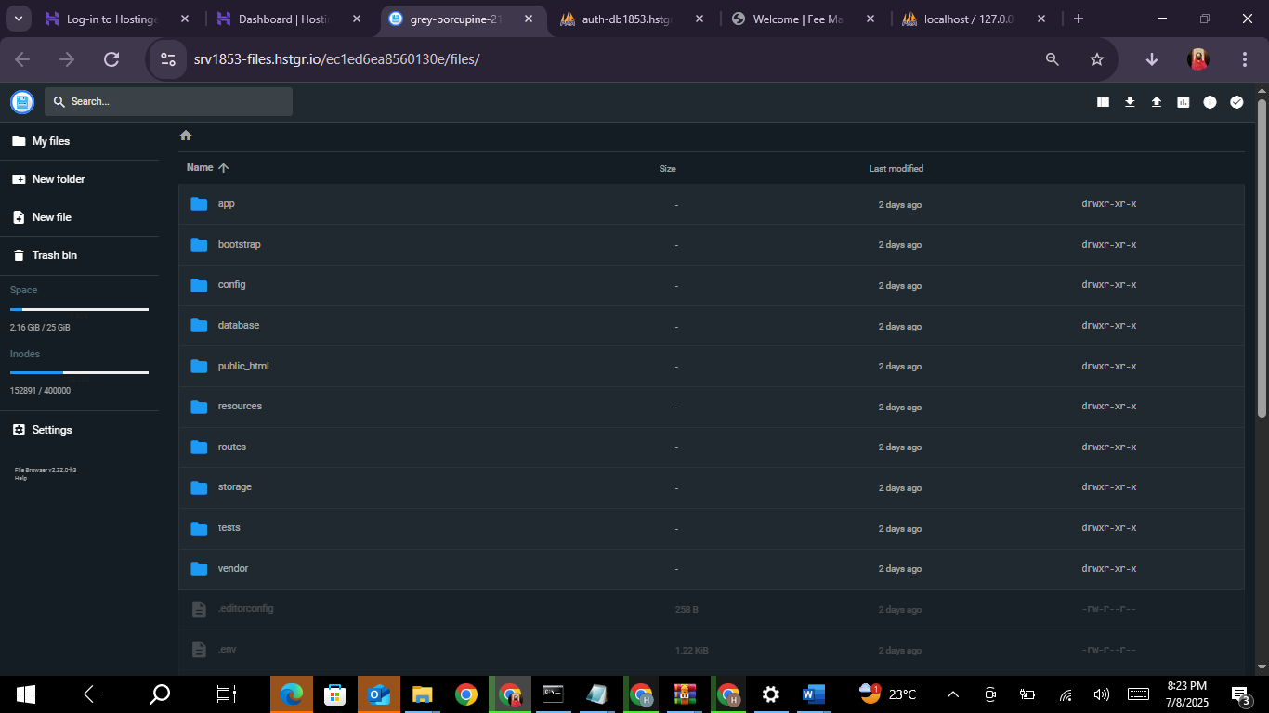

* Files included in public folder of your database should be in public_html

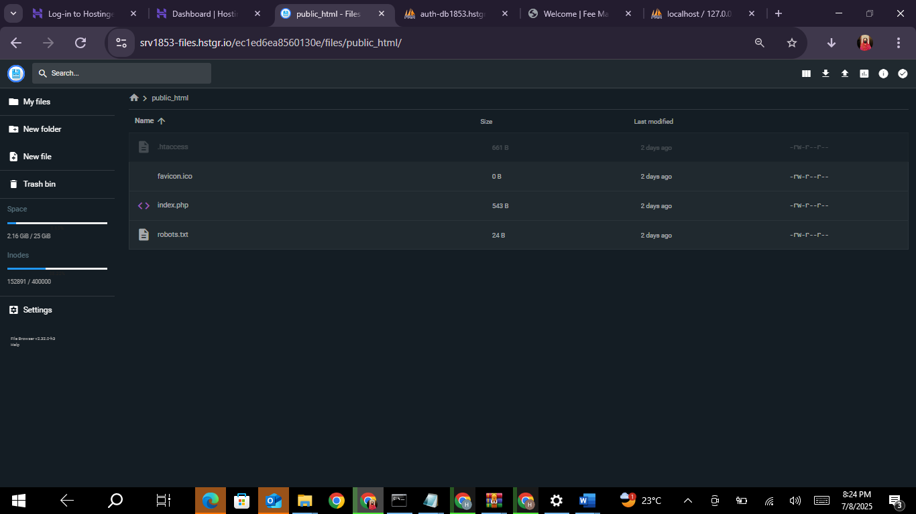

public_html

**Step 4:** Make database connections in .env file

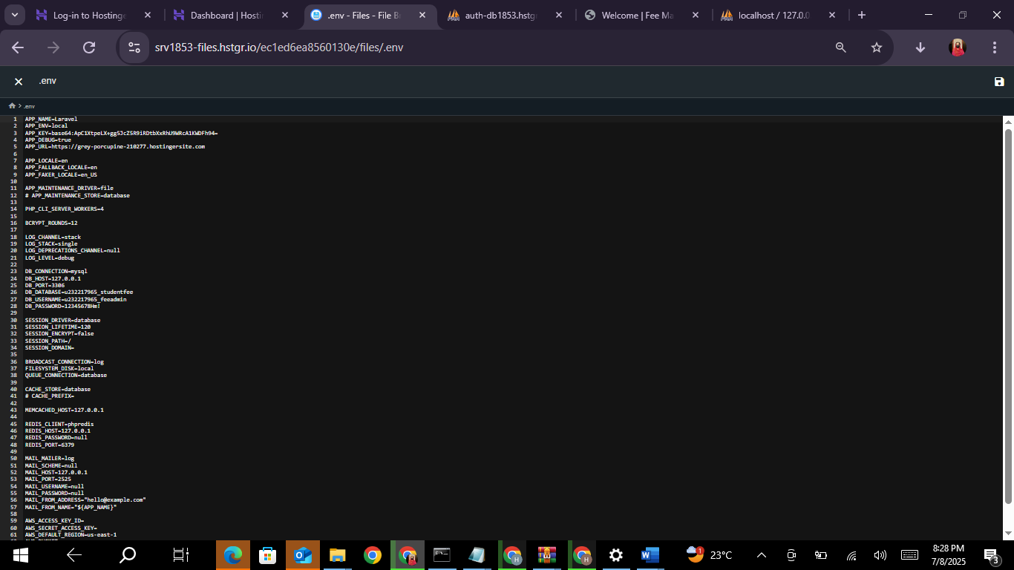

**Step 5:** Enter the link for your website that you have provided in htaccess https://grey-porcupine-210277.hostingersite.com/

